Fundamentals of RISC-V ISA 1
1. Title 1
2. Objective 2
3. Theory (Multi-Level) 2
3.1 Beginner — Simple Intuition 2
3.2 Intermediate — Engineering View 2
3.3 Advanced — Signal/Architecture Level 2
4. Architecture / Concept 3
PicoRV32 CPU Block Diagram 3
Instruction Flow (Fetch → Decode → Execute → Memory → Writeback) 4
5. Implementation 4
Files in This Module 4
How It Works in This Project 4
6. Lab / Hands-on Section 4
Prerequisites 4
Step-by-Step Commands 4
7. Waveform / Verification Insight 5
What to Observe in GTKWave 5
Key Observations 5
ROM Content at Boot 6
8. Common Issues & Debug Tips 6
Debug Tip: Check Instruction Encoding 6
9. Summary 6

Fundamentals of RISC-V ISA
Course: PicoRV32 SoC with AXI-Lite & UART Integration

1. Title
Fundamentals of RISC-V ISA — Understanding Instruction Execution with PicoRV32

2. Objective
By the end of this module, learners will be able to:
- Explain the RISC-V base integer ISA (RV32I) and its register file
- Describe how instructions are encoded in 32-bit words
- Observe PicoRV32 CPU executing instructions through simulation
- Understand the native memory interface (mem_valid/mem_ready) used by PicoRV32
- Read and interpret basic RISC-V waveforms in GTKWave

3. Theory (Multi-Level)

3.1 Beginner — Simple Intuition
Think of RISC-V as a set of very simple cooking instructions your CPU follows, one at a time:
- ADD x1, x2, x3 → “Take the number in shelf x2, add the number in shelf x3, put the result on shelf x1”
- LW x4, 0(x1) → “Go to the address in x1, pick up a 32-bit value, put it in x4”
The CPU (PicoRV32) has 32 shelves (registers, named x0 – x31) and runs through instructions stored in memory one by one. It is a RISC (Reduced Instruction Set Computer) processor — meaning each instruction is small, simple, and takes a predictable amount of time.

3.2 Intermediate — Engineering View
RV32I Base ISA defines: - 32 general-purpose registers (x0–x31), each 32 bits wide. x0 is hardwired to zero. - 6 core instruction formats: R, I, S, B, U, J — all 32 bits wide - Instructions: load/store, arithmetic/logical, branches, jumps, and system calls
Instruction Format | Fields | Example Instructions
R-type | opcode, rd, funct3, rs1, rs2, funct7 | ADD, SUB, AND
I-type | opcode, rd, funct3, rs1, imm[11:0] | ADDI, LW, JALR
S-type | opcode, imm[4:0], funct3, rs1, rs2, imm[11:5] | SW, SB
B-type | opcode, offset, funct3, rs1, rs2 | BEQ, BNE
U-type | opcode, rd, imm[31:12] | LUI, AUIPC
J-type | opcode, rd, imm[20:1] | JAL
Program Counter (PC): Starts at 0x00000000 (PROGADDR_RESET in PicoRV32). Every instruction fetch increments PC by 4 bytes.

3.3 Advanced — Signal/Architecture Level
PicoRV32 uses a native memory interface (not AXI at this stage):
Signal Direction Width Description
------- --------- ----- -----------
mem_valid CPU→Mem 1 CPU asserts when address is valid
mem_instr CPU→Mem 1 High for instruction fetch
mem_ready Mem→CPU 1 Memory asserts when data is ready
mem_addr CPU→Mem 32 Address being accessed
mem_wdata CPU→Mem 32 Write data
mem_wstrb CPU→Mem 4 Byte write strobe (0xF=full word)
mem_rdata Mem→CPU 32 Read data returned to CPU
The handshake is simple: CPU asserts mem_valid, keeps it high; memory processes the request and asserts mem_ready for one cycle; CPU latches mem_rdata. This is a stall-based protocol — if memory is slow, mem_ready stays low and the CPU pipeline stalls.
In the standalone PicoRV32 test (rtl/PicoRV32/), a simple on-chip memory answers immediately, making mem_ready follow mem_valid in one cycle.

4. Architecture / Concept

PicoRV32 CPU Block Diagram
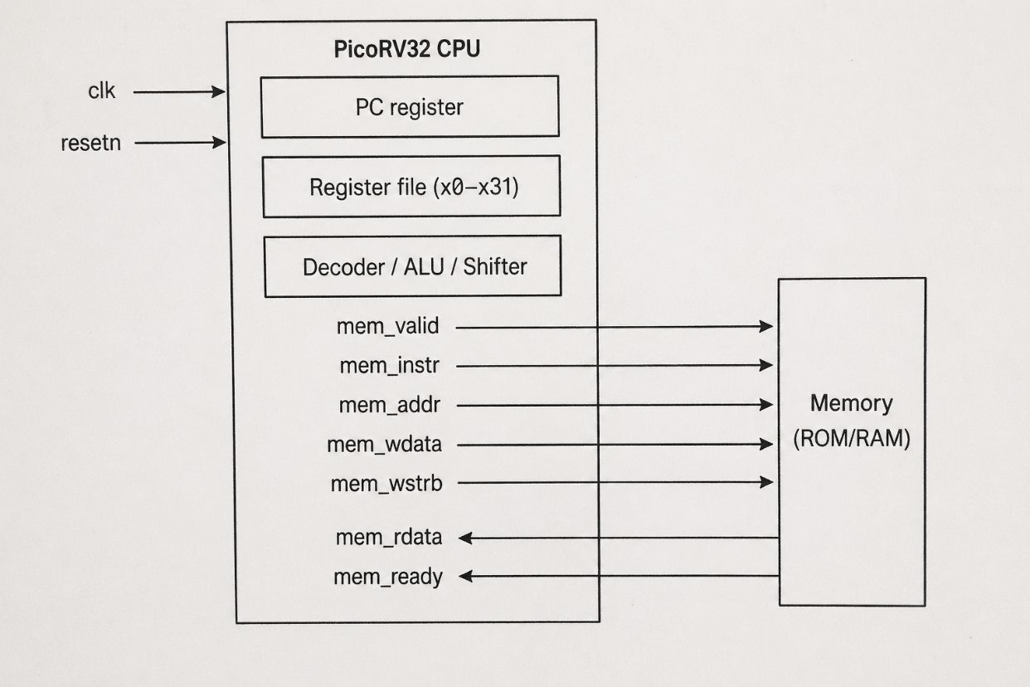

Key design parameters (from rtl/top.v instantiation):
.ENABLE_COUNTERS (1), // Cycle/instret counters enabled
.ENABLE_REGS_16_31 (1), // Full 32-register file
.CATCH_MISALIGN (1), // Trap misaligned accesses
.CATCH_ILLINSN (1), // Trap illegal instructions
.PROGADDR_RESET (32'h0000_0000), // Boot address
.STACKADDR (32'h0001_00FC) // Stack top

Instruction Flow (Fetch → Decode → Execute → Memory → Writeback)
Cycle 1: mem_valid=1, mem_instr=1, mem_addr=0x0000_0000 (Instruction Fetch)
← mem_ready=1, mem_rdata=0x00020137 (LUI x2, 0x20)
Cycle 2: Decode 0x00020137 → LUI x2, imm=0x20000
Execute: x2 ← 0x0002_0000
Cycle 3: mem_valid=1, mem_instr=1, mem_addr=0x0000_0004 (Next IF)
← mem_ready=1, mem_rdata=0xFFC10113 (ADDI x2, x2, -4)

5. Implementation

Files in This Module
File | Role
rtl/PicoRV32/picorv32.v | Main PicoRV32 CPU RTL (the processor itself)
rtl/PicoRV32/Memory.v | Simple instruction + data memory
rtl/PicoRV32/top.v | Top wrapper connecting CPU to memory
rtl/PicoRV32/tb_processor.v | Testbench for isolated PicoRV32 simulation

How It Works in This Project
- The standalone test (make pico) runs PicoRV32 with a dedicated instruction memory containing a simple RISC-V assembly program (arithmetic, loads, stores).
- The testbench (tb_processor.v) monitors mem_valid/mem_ready and dumps signals to tb_picorv32.vcd.
- The firmware used in Sub-modules 7/8 is compiled by riscv32-unknown-elf-gcc targeting RV32I and loaded into rom.hex.

6. Lab / Hands-on Section

Prerequisites
# Ensure tools are installed
verilator --version # >= 4.220
gtkwave --version
riscv32-unknown-elf-gcc --version

Step-by-Step Commands
Step 1: Navigate to project root
cd /home/deep/nielit/projects/tested_projects/picorv32_soc
Step 2: Run the PicoRV32 standalone simulation
make pico
This does: 1. Builds the standalone RISC-V firmware in rtl/PicoRV32/ 2. Compiles all RTL + testbench with Verilator (--binary --trace --timing) 3. Runs the simulation binary → produces tb_picorv32.vcd 4. Opens GTKWave automatically
Step 3: Observe the simulation output
Expected terminal output:
[ROM] loaded from parameter: ...
-- Simulation Complete --
Step 4: View waveforms
make wave
or directly:
gtkwave tb_picorv32.vcd &
Step 5: Clean build artifacts
make clean

7. Waveform / Verification Insight

What to Observe in GTKWave
Open tb_picorv32.vcd and add these signals to the waveform window:
clk
resetn
mem_valid
mem_instr
mem_ready
mem_addr [31:0]
mem_wdata [31:0]
mem_wstrb [3:0]
mem_rdata [31:0]

Key Observations
Signal Pattern | What It Means
mem_valid=1, mem_instr=1 | CPU is fetching an instruction
mem_valid=1, mem_instr=0, mem_wstrb≠0 | CPU is performing a store
mem_valid=1, mem_instr=0, mem_wstrb=0 | CPU is performing a load
mem_ready=0 for multiple cycles | Memory stall (pipeline waits)
mem_addr incrementing by 4 | Sequential instruction execution

ROM Content at Boot
The first instruction at 0x00000000 is 0x00020137 = LUI x2, 0x20, which sets up the stack pointer to 0x00020000. You can verify this in the waveform by checking mem_rdata when mem_addr=0x00000000.

8. Common Issues & Debug Tips
Issue | Likely Cause | Fix
make pico fails — tool not found | Verilator/GCC not in PATH | Source your tools: source ~/oss/environment
tb_picorv32.vcd not generated | Verilator --trace missing | Check VLFLAGS in Makefile includes --trace
Simulation ends immediately | ROM is all NOPs (0x00000013) | Check the firmware was compiled in rtl/PicoRV32/
GTKWave shows flat signals | Wrong VCD file opened | Confirm file path; use ls -la *.vcd
CPU stalls forever | mem_ready never asserts | Check memory module wiring in top.v
trap signal goes high | Illegal instruction or misaligned access | Check firmware ELF for undefined behavior

Debug Tip: Check Instruction Encoding
To decode any mem_rdata value manually:
# Quick decoder (Python)
instr = 0x00020137
opcode = instr & 0x7F # = 0x37 = LUI
rd = (instr >> 7) & 0x1F # = x2
imm = instr >> 12 # = 0x20
print(f"LUI x{rd}, 0x{imm:05X}")

9. Summary
Topic | Key Takeaway
RISC-V ISA | 32-bit fixed-length instructions, 32 registers, 6 formats
PicoRV32 | Open-source RV32I implementation, simple stall-based memory interface
Native memory bus | mem_valid/mem_ready handshake; stall if memory is slow
Boot address | PROGADDR_RESET = 0x00000000; stack at 0x0001_00FC
Lab result | tb_picorv32.vcd shows full instruction pipeline including IF, EX, MEM
This module establishes the foundation that all subsequent modules build upon. The PicoRV32 CPU’s native memory interface (mem_valid/mem_ready) is converted to AXI-Lite in Sub-module 5 — this translation is the core bridge of the entire SoC.

Next Sub-module → Sub-module 2: Introduction to AXI-Lite

